|  |
| --- |
| Author/Date: Modified by____________________________________________________________Daniel Eibach Charity Wiafe Akenten |
| **Reviewed/Approved by/Date:**  ____________________________________________________________ |

**This SOP has been read and understood by:**

|  |  |  |
| --- | --- | --- |
| **Name** | **Signature** | **Date** |
|  |  |  |
|  |  |  |
|  |  |  |
|  |  |  |
|  |  |  |
|  |  |  |
|  |  |  |
|  |  |  |
|  |  |  |
|  |  |  |

# 

**INTRODUCTION**

The large-volume methods once used for microbial characterization tests have been miniaturized and presented in different easy-to-use formats. The API 20NE Test is one of these formats used in the identification of glucose non-fermenters, Parvobacteriaceae and Vibrios.

**PRINCIPLE**

Each test strip consists of 20 cupules containing dehydrated substrates of biochemicals. A saline suspension of bacteria is added and the test strip is incubated overnight. Indicator reagents are added to appropriate cupules and all the reactions assessed positive or negative. The results of the tests are allocated scores in such a way that every possible combination of results produces a unique code. This code is looked up on a database; the APIWeb data base to give an identification of the organism.

**SCOPE**

This Standard Operating Procedure applies to the use of the API NE test strip by technical staff in the microbiology laboratory, which has been trained and is competent in performing this procedure.

**MATERIALS**

* API NE Test kit (25 tests/kit)
* Test strips (1 per isolate)
* API AUX ampoule
* Plastic trays
* Result forms
* Sterile saline – 2 ml
* Sterile loops
* Pasteur pipettes
* Sterile water
* Mineral oil
* James Reagent
* Ninhydrin 1 (NIT1)
* Ninhydrin 2 (NIT2)
* Fresh (18-24 hr) culture of test organism.

**SAFETY**

* APIs on class three organisms must be inoculated in the exhaust protective cabinet (EPC) and placed in a minigrip plastic bag prior to incubation.
* Use the protective plastic guard when opening ampoules of suspension medium or reagents, to prevent injury.
* Do not stack loaded carriers more than two high when incubating to minimize the risk of their falling over.

**PROCEDURE**

Preparation of bacterial suspension

* Using a sterile loop, touch the center of one well-isolated colony and add to an ampoule of 2 ml saline, making sure that the density of the inoculum is 0.5 McFarland.
* Emulsify to achieve a homogenous suspension.

Preparation of Test Strip

* Label the API carrier tray with the patient’s barcode.
* Add 5 ml of sterile distilled water into the tray to provide a moist atmosphere, which prevents drying of the strip.
* Remove the API strips from the sealed envelope and place a strip in the incubation tray.

Inoculation of the Strips

* Each NE strip contains 20 microtubules each of which consists of a tubule at the bottom and cupule section at the top.
* Slightly tilt strip to fill along the wall of the tubule to avoid bubble formation.
* Using a sterile Pasteur pipette, fill the microtubules with the prepared saline suspension as follows:
* Inoculate the NO3 to PNPG (the first 8 cupules) from the saline suspension.
* Streak a loopful of this bacterial suspension to a McConkey/CLED agar for purity check. Incubate plate overnight at 35oC-37°C in air.
* Open an API AUX ampoule (provided with the kit) and add 4 drops of the saline suspension to It. Use the pipette to mix well without creating bubbles.
* *API AUX medium is a minimal medium with no carbon source. Organisms grow only if they are able to utilize the substrate present in the cupule. .
* Use this suspension to inoculate the remainder of the cupules.
* Overlay wells with liquid paraffin where indicated.
* Incubate overnight in air at 35ºC-37°C.

**RESULTS**

The following day examine the purity plate after overnight incubation, ensuring the culture is pure then add the reagent as follows:

|  |  |
| --- | --- |
| **Well** | **Reagent** |
| NIT | One drop of NIT1 and one drop of NIT2 and wait 5 minutes. If there is no reaction, add zinc powder, wait 5 minutes and interpret according to the flow chart on page 10. |
| James’s Reagent | One drop of James’s reagent and read after 3-5 minutes |

* Examine the assimilation test for bacterial growth. An opaque cupule indicates a positive reaction. Occasionally, a cupule may show weak growth. In this case the result should be noted as +/- or-/+ by comparison to other tests on the strip. Once these readings have been made, identification should be possible.
* Read the results from the interpretation table-APPENDIX A 4. Enter the patient’s barcode and the date on an API result form.
* Assess the outcome of the biochemical reaction in each cupule and record the result on the API form (see Interpretation table Appendix A).
* Calculate a 7 digit profile number by adding up the numbers of the cupule values of positive reactions in each triplet of tests.
* Look up identification in the APIWeb data base.

In the following cases, the strip must be re-incubated:

* If the profile cannot be found in the profile index
* If the following note is printed for the profile obtained:

**IDENTIFICATION NOT VALID BEFORE 48 HOURS INCUBATION**

1. In either of these events, immediately fill the NO3 and TRP wells with mineral oil so that a jj convex meniscus is formed, to prevent escape of acidic vapour. Reincubate the strip at 35ºC37°C in air for a further 18-24 hours and read all the tests once more excepting NO3, TRP and GLU which must be read once only, at 18-24 hours.

Re-read the tests and construct a new profile.

**Accessing APIWeb .**

* Load the CD into the CD drive.
* Click on the APIWeb icon to connect to website.
* Select API 20NE.
* Enter the study (REF) number.
* Enter the octal code in spaces provided.
* Select CONFIRM.
* Print a copy of the APIWeb report.

**Then:**

1. If EXCELLENT IDENTIFICATION OR VERY GOOD IDENTIFICATION - Report results.
2. If ACCEPTABLE IDENTIFICATION OR GOOD LIKELIHOOD, LOW SELECTIVITY - Perform additional tests when possible and consult supervisor if at least “Very Good” identification is not achieved.

**QUALITY CONTROL**

**Frequency**: Each lot/shipment of kits before use.

**Control:** ATCC Pseudomonas *aeruginosa* #27853

**Acceptable Results**: Appropriate reactions in all biochemical (see API 20NE QC sheet) **Corrective Actions for Unacceptable QC Results**:

1. Repeat test with fresh subculture of frozen organism stock, passed twice.
2. If still unacceptable, contact manufacturer for replacement. Do not use for patient testing.

**DOCUMENTATION:**

1. Record results on API 20NE QC sheet.
2. Supervisor will review QC results monthly.

**REFERENCES**

Package Insert, 2004, API 20NE, bioMerieux, Inc., Durham, NC.

**APPENDIX A** – API 20NE Interpretation Table

**APPENDIX B** – API 20NE QC sheet

**APPENDIX A**

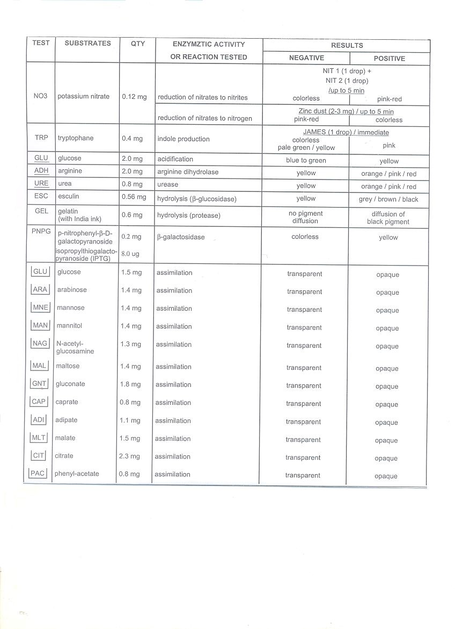

**A**

**PI 20**

**NE I**

**nterpretation**

**T**

**able**